[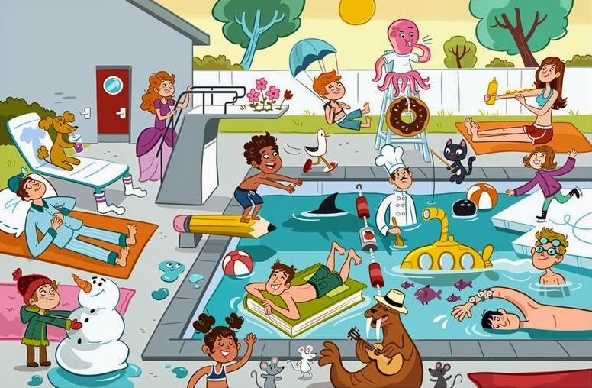](https://www.google.pl/url?sa=i&url=http%3A%2F%2Fticzmi.blogspot.com%2F2016%2F09%2Fpresent-continuous-opis-obrazka.html&psig=AOvVaw1IZlh9P_DXfxAqSAjDggSq&ust=1585414110748000&source=images&cd=vfe&ved=0CAIQjRxqFwoTCKiJwP6Nu-gCFQAAAAAdAAAAABAN)

[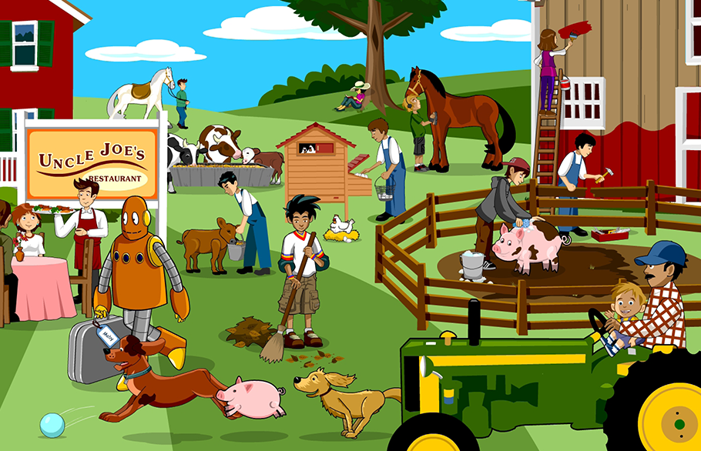](https://www.google.pl/url?sa=i&url=http%3A%2F%2Fticzmi.blogspot.com%2F2016%2F09%2Fpresent-continuous-opis-obrazka.html&psig=AOvVaw1IZlh9P_DXfxAqSAjDggSq&ust=1585414110748000&source=images&cd=vfe&ved=0CAIQjRxqFwoTCKiJwP6Nu-gCFQAAAAAdAAAAABAW)  
  
  
  
  
  
  
  
  
  
  
  
  
  
  
  
  
  
  
  
  
  
  
  
  
  
  
  
  
  
  
  
  
  
  
  
  
  
  
  
  
  
  
  
  
  
  
  
[](https://www.google.pl/url?sa=i&url=http%3A%2F%2Fsmallthingswithgreatheart.blogspot.com%2F2017%2F06%2F&psig=AOvVaw1IZlh9P_DXfxAqSAjDggSq&ust=1585414110748000&source=images&cd=vfe&ved=0CAIQjRxqFwoTCKiJwP6Nu-gCFQAAAAAdAAAAABAI)